**Test plan**

|  |  |  |  |  |
| --- | --- | --- | --- | --- |
| id | description | Expected input | Expected output | Actual output |
| 1 | Add contact | Name,email, phone no,  address | Contact saved | Contact saved |
| 2 | Search contact | Name | Contact found | Contact found |
| 3 | Delete contact | Name | Deleted contact | Deleted from list |
| 4 | List of contacts | List option number | Display list of contacts | Displays all  conatcts |

Home page

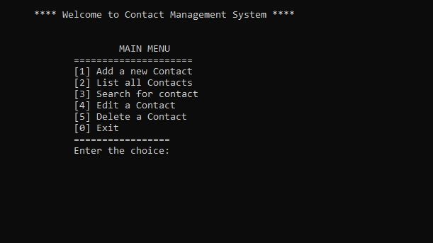

Add contact

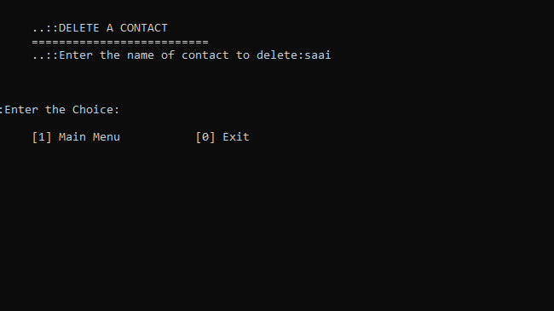

Delete contact

